Topic: HIV and AIDS / Sexual health
Level: Entry level 2 - 3 / Scottish Access 3 – National 4 / CEFR A2 - B1
Time: 90 minutes

Aims
- To extract meaning from specialised health leaflets
- To develop students’ range of vocabulary related to health

Objectives
Learners will be able to:
- Read and understood a simple health leaflet
- guess the meaning of new vocabulary from context
- speak about suggestions to improve health
- plan and write a simple text about health

Introduction
This lesson develops reading skills within the context of reading a health leaflet about HIV and AIDS. The reading text has been adapted from Skilled for Health resources found at: https://api.excellencegateway.org.uk/resource/etf:2084/0

You will need:
- Resource 1: copy to project or large copy to display
- Resource 2 to 4: 1 copy per learner
- Additional information: 1 copy per higher level learner where relevant
- Some health leaflets (from prison or outside)
- Whiteboard (traditional or interactive) or flipchart paper

Note: Firstly, be aware that not all ESOL learners will be comfortable talking about sexual health. This may be due to cultural or religious reasons related to their background. Secondly, teachers need to careful not to assume knowledge about sexual health issues and realise that there are many preconceptions about HIV and AIDS.

Procedure
Warmer (10 minutes)
- Write a well-known acronym on the board, such as BBC, ITV, FIFA, EU or a prison-related acronym (HMP, PID). Choose acronyms that are universal and do not assume cultural knowledge of the UK (some prisoners may have come directly from the airport).
- Ask learners why the letters are capitalised and elicit what the letters mean. Learners may not know what the letters stand for, but do make sure that they understand that each letter represents a word.
- Write HIV and AIDS on the board and ask if they know what they mean. Ask if these acronyms are new to learners or if they are written differently in their language (for example, in French HIV is VIH).
- Elicit that you say the individual letters when you say HIV but that AIDS is pronounced as one word.
- Elicit what learners know about HIV and AIDS. If learners have very little knowledge tell them they are going to practise reading health leaflets in prison and will start by reading one that is about what HIV and AIDS.
- Explain that the V in HIV is for virus. Check understanding of the word ‘virus’ by putting the following words on the board: flu, measles, headache, heart attack. Put the learners in pairs and ask them to discuss which are caused by viruses.
- Take feedback and further check understanding with the questions: ‘What happens when you catch a virus?’ (Suggested answer: you get sick) How can we catch viruses? Is there only one way to catch viruses?’ (Suggested answers: shaking hands, coughing, sneezing, etc.)

Activity 1: Pre-teach vocabulary/ concept of health leaflets (5 minutes)
- Elicit where you might see information about HIV and AIDS.
- Tell the learners that the text gives information about HIV and AIDS. Ask where they might find information about HIV and AIDS (e.g. in a leaflet in the healthcare department of a prison or in a GP surgery outside).
- Show a few health leaflets to help learners understand what they are and what they look like. Ask why you would read them.
- Hand out Resource 1 and elicit the words condom and needle / syringe.
Activity 2: Vocabulary: understanding words from context (15 minutes)
- Hand out Resource 3 and ask learners to focus on the highlighted words in the text.
- Explain we don’t always need a dictionary or someone to help us when we don’t understand a new word. Focus on number 5 (virus) and elicit the meaning.
- Hand out Resource 2 and ask learners to find the meaning for number 5 in pairs then check the answer.
- Tell learners to find the rest of words from Resource 3 and match them with the definitions in Resource 2.
- Feedback correct answers or give learners correct version to check in pairs.

Extension
- Encourage early finishers to search for more new words or phrases and try to work out their meaning from context.

Activity 2: Reading – matching the headings (10 minutes)
- Focus on Resource 3 (matching the headings 1 to 3 with the paragraphs).
- Explain that learners should focus on getting the gist of it in order to match the three headings with each section. Learners should work individually. Set a time limit to read the text (depending on your group, three minutes might be appropriate)
- When learners are finished, tell them to swap with a partner and compare answers before feeding back to the whole group.

Activity 3: Reading – true or false? (10 minutes)
- Tell the learners that they are going to read the text in more detail to answer true or false questions.
- Nominate learners to read the statements out loud then set the task.
- Put the learners into pairs to read the statements and predict which paragraph they will find the answer in. Next ask learners to do task in pairs.
- Review the answers together. When eliciting the answers, nominate specific learners so that everyone contributes.

Differentiation
- To support lower-level learners, you could indicate where in the text the answer can be found.
- Ask early finishers to mark where in the text they found the answers.

Extension
- During feedback, invite learners to explain the reason for their answers and where they were found.

Activity 4: Speaking: plan to write a health leaflet (10 minutes)
- Focus attention on one of the health leaflets you brought to the class.
- Tell the learners that they are going to make a health information leaflet about how to stay healthy in prison.
- As a group, elicit ideas about how to be healthy in prison. Write these on the board perhaps as a mind map or in categories (such as food, exercise, sleep, hygiene).
- Put the learners in pairs and give more time for them to think of ideas.

Differentiation
- You may want to consider pairings so that each pair has enough experience of prison life to complete the task.

Activity 5: Writing – making a health leaflet (25 minutes)
- Ask learners to look again at the text on Resource 3. Encourage them to think about how the text is structured; ask, for example, ‘How is the text organised? How many headings are there? What are the black dots at the side of the text in part 2 (bullet points)? Why do we use them?’
- Set the title of the leaflet as ‘How to stay healthy in prison’ and ask each pair to choose three headings (based on their ideas so far).
- Give a suitable amount of time for learners to draft their leaflet e.g. 20 minutes.

Differentiation
- During pair work, give necessary support to help learners structure their ideas and write their leaflets.

Cooler: Speaking – staying healthy in prison (5 minutes)
- Ask learners to choose what they think is the most important thing you can do to stay healthy in prison.
- Nominate learners (perhaps randomly) to share their idea with the group.

Differentiation
- You could give a sample sentence to help, such as ‘I think exercising regularly is the best way to stay healthy in prison because…’

Extension activities/ homework
- Learners may need more time to finish their leaflets. You could set the task of finishing the leaflet as homework or in the next lesson.
- If your learners would enjoy it, they could create posters containing the information in the leaflets to use as a display or to add pictures to.
- Following on from task 5, you could ask each pair to create three questions about their leaflet. Then each pair could swap texts and find the answers to the questions.

Answer key

Resource 1
condom, needle/syringe

Resource 2
1 – weak, 2 – condom, 3 – immune system, 4 – unprotected sex, 5 – virus, 6 – barrier, 7 – barrier

Resource 3
1 – b, 2 – c, 3 – a

Resource 4
1 – T, 2 – F, 3 – F, 4 – T, 5 – T

Resource 1: Vocabulary

What are these things? What are they used for?

Write the names next to the pictures.

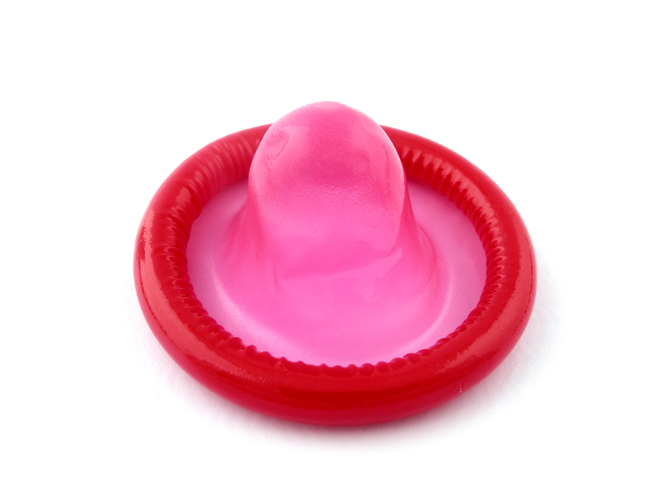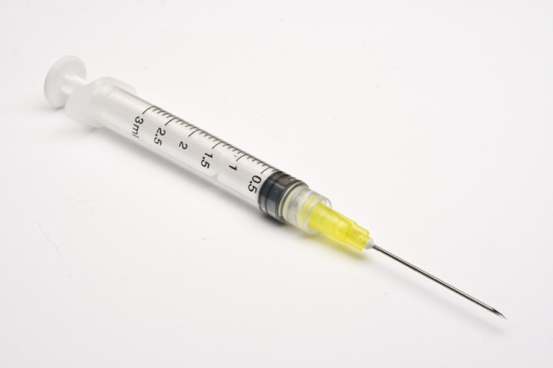

Resource 2: Vocabulary – understanding words from context

Match the highlighted words from the text (in worksheet 3) with the meanings below.

- weak (adj) not healthy; not effective or powerful
- _______________(noun) something a man can wear on his penis during sex
- _______________(noun) the part of your body that protects you from illness
- _______________(noun) having sex without a condom
- _______________(noun) a kind of germ that causes diseases such as HIV

- _______________(noun) an object or layer that stops something moving from from one place to another

- _______________(adj) something that has stopped working properly is…
Extra task: find as many words in the text that mean illness.

Resource 3: Reading – matching the headings

There are no headings in the text. Read the text quickly and match the correct headings (a-c) with the paragraphs below (1-3).

- How to protect yourself from HIV and AIDS
- What are HIV and AIDS?
- How do people get HIV?

The facts about HIV and AIDS*

- What are HIV and AIDS?
HIV is a virus that attacks the body’s immune system. It makes the immune system so weak that it cannot do its job properly, that is to fight illnesses. Most of the people infected with HIV got it by having unprotected sex with a person who had the virus.

AIDS is what someone gets after having HIV for some time. It means that their immune system is badly damaged by HIV.

HIV and AIDS are not the same thing. Someone who has HIV can live for many years before getting AIDS. Not everyone who has HIV gets AIDS.

- ____________________
The main ways for people to get HIV are:
- unprotected sex (sex without a condom) with someone who has HIV
- sharing needles and syringes for taking drugs (such as heroin or steroids) with someone who has HIV
- from mother to child. Pregnant women who have HIV have advice about not passing on the virus to their baby.

- ____________________
Most people who have HIV were infected because they had unprotected sex. A condom is a very good barrier to the HIV virus if you use it correctly, and every time you have sex.

*Text adapted from http://rwp.excellencegateway.org.uk/resource/Health+and+well-being%3A+Sexual+health+-+Theme+3+HIV+and+AIDS/pdf/1/

Resource 4: Reading – true or false?

Read the text again. Write T (true) or F (false) next to each statement.

- You can catch HIV from having unprotected sex with someone who has the virus.
- AIDS is the same as HIV.
- Sex is the only way to get HIV.
- Men and women can get HIV.
- Wearing a condom during sex can protect you from catching HIV.

Additional information (for teachers or learners)

The following information has been provided courtesy of:
http://rwp.excellencegateway.org.uk/resource/Health+and+well-being%3A+Sexual+health+-+Theme+3+HIV+and+AIDS/pdf/1/

You cannot get HIV:

- by kissing, hugging and touching someone who has HIV
- by sharing cups/glasses and crockery with someone who has HIV
- by eating food prepared by someone who has HIV
- from toilet seats
- insect bites.

Glossary

AIDS - A medical condition. Stands for Acquired Immune Deficiency Syndrome
Contraception - Something you do to stop conception, stop a baby growing
Contraceptive - Anything which stops pregnancy
Gonorrhoea - Sometimes called ‘the clap’; an STI caused by bacteria that can cause a lot of damage
HIV - Short form of Human Immunodeficiency Virus. Can cause AIDS
HIV positive - This describes someone who has had an HIV test and the result is positive. This means they have HIV
Immune system - The system your body develops to defend and protect itself from infections and diseases
Safer sex - Sex where you do not allow your partner’s body fluids into your body. It can also mean covering up or avoiding contact with parts of the body that might be infectious
STI - Short form of Sexually Transmitted Infection’

